

Advanced search orders

Functional Design Document

Document History

|  |  |  |  |
| --- | --- | --- | --- |
| **Version** | **Updated by** | **Date** | **Comments** |
| V1.0 | Sisi Wang | 12/05/2015 | Creation |
| V2.0 | Hamzi Boudiaf | 13/05/2015 | Update |
|  |  |  |  |
|  |  |  |  |
|  |  |  |  |
|  |  |  |  |
|  |  |  |  |

Document Sign-off

|  |  |  |  |
| --- | --- | --- | --- |
| **Name** | **Role** | **Date** | **Signature** |
| **Pascal ESPINOUSE** |  |  |  |
| **Florent ESTUPINA** | Hybris developer | 19/05/2015 | Validation |
|  |  |  |  |
|  |  |  |  |
|  |  |  |  |

Document references

|  |  |  |  |
| --- | --- | --- | --- |
| **Reference and Document Title** | | **Version Number** | **Date** |
|  | CGHA_AdvancedSearchOrders_FDD_V1 0.docx | V1.0 | 12/05/2015 |
|  | CGHA_AdvancedSearchOrders_FDD_V2 0.docx | V2.0 | 13/05/2015 |

# Table of Contents

Table of Contents 2

1 Introduction 3

1.1 Aim of this document 3

1.2 Reading the specifications 3

2 Description 4

2.1 Benefits 4

2.2 Description 4

2.3 Use case 4

2.3.1 Advanced search orders page 4

2.4 Functional details 5

2.4.1 Advanced search orders page - Top 5

2.4.2 Advanced search orders page - Bottom 6

# Introduction

## Aim of this document

The aim of this document is to provide the Functional Requirement Specifications (FRS) corresponding to the Functional description of requirements of the module Advanced Search Orders.

## Reading the specifications

Each functionality is described as follows:

**Alert messages**

* Alert messages postfixed with (*) are given as information. They will be updated globally during the project.

**As a customer, I want to etc.**

* Story description for each functionality.

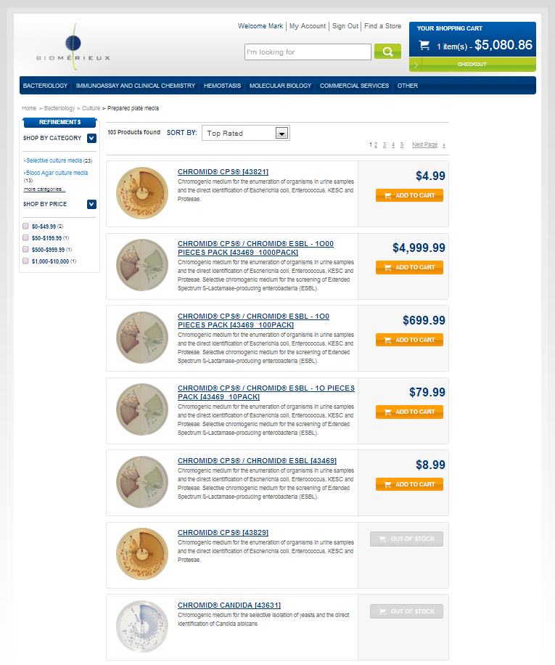

➊

➋

* The screen shot is used to illustrate the functionality.

###### Description - specific

|  |  |
| --- | --- |
| **Name** | **Description** |
|  |  |

* Detailed description for the specific development

# Description

## Benefits

In a B2B site, the users are professional users and 70% of time spent on the internet is spent in the process of finding information.

As a consequence, advanced search functionalities are key to improve customer engagement and increase the sales and order volumes.

## Description

The advanced search for orders enhanced the standard hybris search functionality.

The advanced search orders module is used to search for orders/carts according to different criteria.

The advanced search for orders page is accessible from customer personal space.

## Use case

### Advanced search orders page

As a customer; I want to search for orders or carts according to different criteria.

## Functional details

### Advanced search orders page - Top

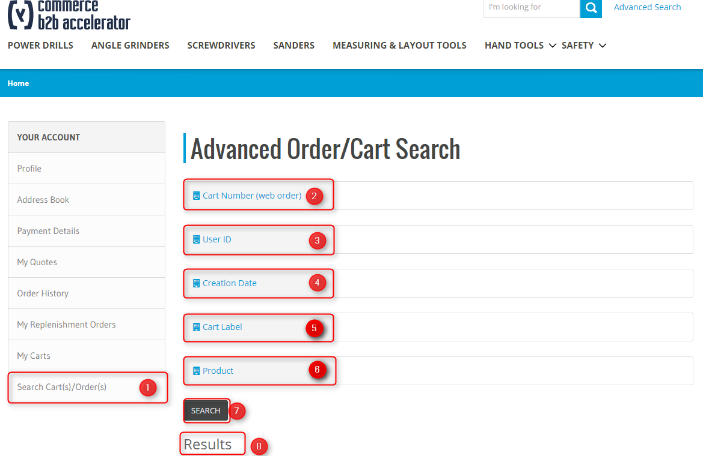 Illustration: Search carts/orders is accessible from customer personal space

###### Description - specific

|  |  |
| --- | --- |
| **Name** | **Description** |
| **Description** | This section explains the functional details about the top of the page “Advanced search cart(s)/order(s)”  If several criteria are filled, the “AND” logic is applied between them. |
| **1 – “Search Cart(s)/Order(s) ” Page** | Click on the “Search Cart(s)/Order(s)” link to get access to Search Carts(s)/Order(s) page. |
| **2 – Cart Number(web order)** | Each cart/order has a unique ID, users need to fill in the field with the unique ID.  For this version, auto completion is not implemented. So the user needs to fill in each field with the accurate information for the search. |
| **3 – User ID** | In hybris, user ID is the email used in user registration.  Since each member of a B2B Unit can access to all the orders and carts created by other members. So a user can use the User ID search criteria to search for orders/carts created by a certain member.  For this version, auto completion is not implemented. Plus user needs to fill in the exact user ID for the search. |
| **4 – Creation time** | When clicking on in the field “Creation time”, a calendar will be shown in a popup.    Then clicking on a date, then this date will be displayed in the “Creation Date” field in text form “DDMMYYYY”. |
| **5 – Cart label** | The multicart module provides the ability to add names to carts.  Since order doesn’t possess a name, so this criteria is only used for searching cart. |
| **6 – Product** | User needs to fill in the field with the unique product number.  For this version, auto completion is not implemented. Plus user needs to fill in the exact Cart/Order Number for the search |
| **7 – Search** | Click on the button to launch the search |
| **8 – Results** | The results section will be explained in details below |

### Advanced search orders page - Bottom

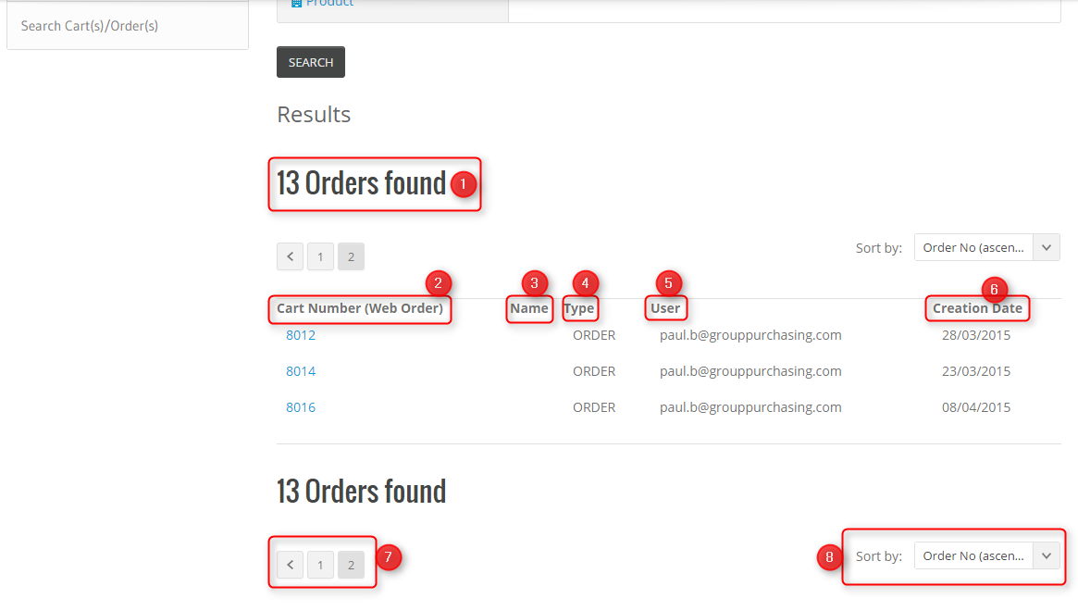

###### Description - Specific

|  |  |
| --- | --- |
| Name | Description |
| 1 – Number of results found | Displays the number of results found. |
| 2 – Cart Number(Web order) | Displays the Cart/Order Number( It should be unique).  The Cart/Order Number is clickable, when clicking on the Cart/Order Number, the user will be brought to the order history detailed page. |
| 3 – Name | Displays the name of the carts, there is no name for orders. |
| 4 - Type | Displays if this is an order or a cart. |
| 5 – User | Displays the ID of the user who placed the order. |
| 6 – Creation Date | Displays the date when the order/cart is created. |
| 7 – Pagination | Displays 10 items per page |
| 8 – Sort by | Sort by Order/Cart numbers, label, data and user  By default, the results are sorted by Order Number (ascending) |